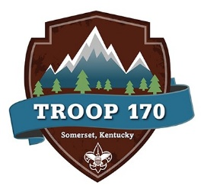
Upcoming Event: Fourth of July Week 2026.
We have a unique opportunity to raise money for the troop and get to a front row seat to some awesome events for our community.
All 4 events will be centered around Scouts catching the American flag and keeping it off of the ground as the sky dive team flies in at each event.
Horse Solider Ribbon Cutting.
Wednesday July 1st and Friday July 3rd. 9:00 AM to 11:00 AM - Possible Opportunity to meet Governor Beshear (Wednesday Only) and tour the new facility. Need 4 Scouts for Each Event.

Friday Evening July 3rd and July 4th Rodeo, Concert & Fireworks Meet at ESBC 5:00 Sharp. Travel to the facility, Free ticket to watch rodeo and concert for Scouts and Participating Adults. Need 10 Scouts and Adults to Drive.
FRIDAY | SATURDAY

